**Big Mountain: Pricing Strategy**

**Abstract**

Using historical data, several models with different predictors were developed to determine the pricing strategy for the Big Mountain lifts. The findings suggest an increase in lift prices. The result shows that it is statistically legitimate to increase current prices.

**Introduction**

Big Mountain Resort has expanded its business by installing new chair lifts, which have increased the operating costs by $1,540,000. The business profit margin is 9.2%, and the investors would like to keep it there. According to management, one way to recover the excess operation cost is by increasing the lift’s tickets. In order to validate if the management decision is supported by the data, several predictive models are built. The result will determine if the decision to increase the prices is valid or not.

**Result and Analyses**

Using historical data, three models were built. The prediction power of all three models is significant enough with a higher than 92% degree of confidence. However, model one prevails higher explained variance as compared to the two other models. It shows higher ‘explained variance’ and lower ‘mean absolute error’. Therefore, model one suffices the statistical criteria and is selected as the best model.

|  |  |  |  |
| --- | --- | --- | --- |
| **Model** | **Explained Variance** | **Mean Absolute Error** | **Features Dropped** |
| Model 1. | 0.930323 | 5.15880 | - |
| Model 2. | 0.92061 | 5.6444 | 'state' |
| Model 3. | 0.92181 | 5.69612 | 'state','summit_elev','base_elev' |

**Finding and Recommendation**

The result from visual exploration shows that the vertical drop and summit elve are classified into three main classifications;

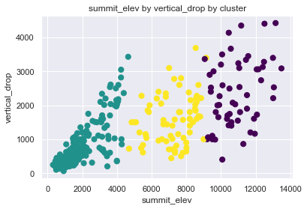

The findings support increasing the Big Mountain lift tickets. Currently, the lift ticket during the weekend is $81/ adults. They can increase the lift tickets to $ 88/ adults. However, further analyses and investigations are needed to determine the ticket price for other products and determine the period in which the company can earn the $1,540,000 extra operation costs.